Case 1, no uniform flow

|  |  |
| --- | --- |
|  | Q\_max, m/d |
| K = k1 | 1.27 \* 10^3 |
| K1 = 10\* k | 5.31\* 10^4 |
| K= 10\* k1 | 72 |
|  |  |

Potential contours:

K=k1

C:\Users\Jack\AppData\Local\Microsoft\Windows\INetCache\Content.Word\Case1_k=k1.tif

K1>k

C:\Users\Jack\Documents\GW modeling\Original work\HW 4\figs\Case1_klessk1.tif

k>k1

C:\Users\Jack\Documents\GW modeling\Original work\HW 4\figs\Case1_kgreaterk1.tif

2.

For k1>>k

|  |  |
| --- | --- |
|  | Q max, m/d |
| Zw=0 | 5.31\* 10^4 |
| Zw=50 | 4.84 \* 10^3 |
| Zw=75 | 4.14 \* 10^4 |

For k1 << k

|  |  |
| --- | --- |
|  | Q max, m/d |
| Zw=0 | 72 |
| Zw=50 | 73 |
| Zw=75 | 75 |

The maximum discharge decreases slightly as the well is placed further from the center of the inhomogeity.

3.

For k1>k

|  |  |
| --- | --- |
| Radius of gravel pack, m | Qmax, m/d |
| .5 | 2.19 \* 10^4 |
| 1 | 2.37 \* 10^4 |
| 1.5 | 2.49 \* 10^4 |
| 3 | 2.73 \* 10^4 |
| 5 | 2.94 \* 10^4 |

The maximum discharge of the well increases somewhat as the size of the gravel pack around it increases.

Case 2, uniform flow left to right

|  |  |
| --- | --- |
|  | Q\_max, m/d |
| K = k1 | 1.27 \* 10^3 |
| K1 = 10\* k | 5.79 \* 10^4 |
| K= 10\* k1 | 6.79 |
|  |  |

Head contours:

K=k1

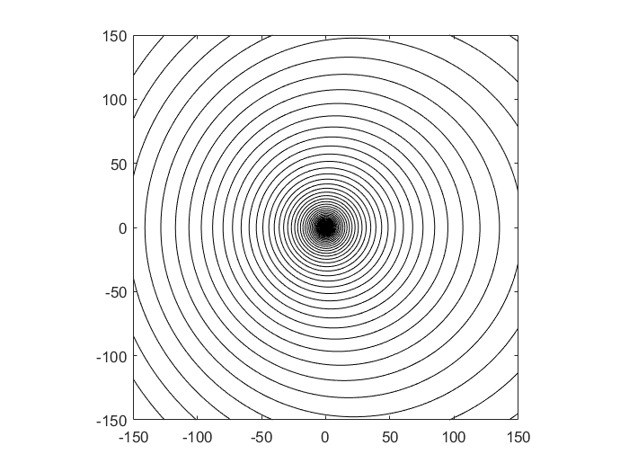

K1>k

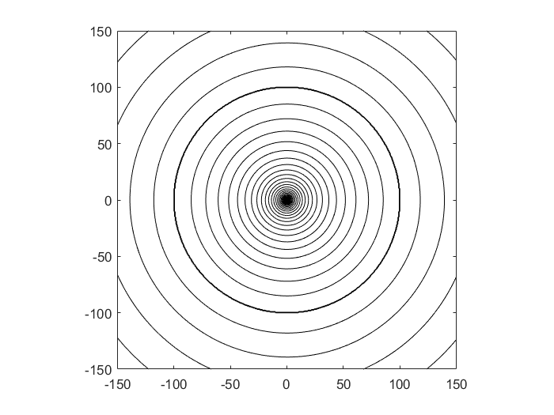

k>k1

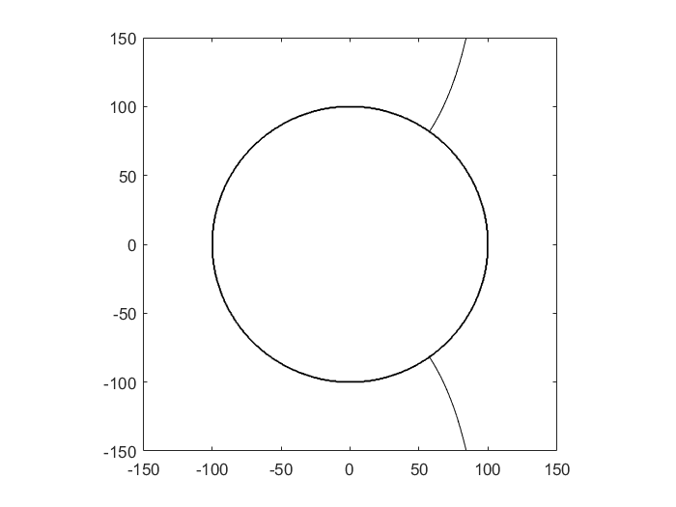

2.

For k1>>k

|  |  |
| --- | --- |
|  | Q max, m/d |
| Zw=0 | 5.79 \* 10^4 |
| Zw=50 | 5.25 \* 10^4 |
| Zw=75 | 4.48 \* 10^4 |

For k1 << k

|  |  |
| --- | --- |
|  | Q max, m/d |
| Zw=0 | 6.79 |
| Zw=50 | 6.19 |
| Zw=75 | 6.0 |

3.

For k1>k

|  |  |
| --- | --- |
| Radius of gravel pack, m | Qmax, m/d |
| .5 | 2.39 \* 10^4 |
| 1 | 2.59 \* 10^4 |
| 1.5 | 2.72 \* 10^4 |
| 3 | 2.92\* 10^4 |
| 5 | 3.212 \* 10^4 |

Code:

**Main.m**:

%case 1: no uniform flow

%Parameters

k = 10;

k1= 10; %m/d

zw =0;

rw = 0.05;

R = 100; %m

Rinf = 10\*R;

Qx0 = 0; %No uniform flow

PhiInf = .5 \* k \* 20\*20;

z = zw+rw;

%calculate maximum discharge

Q\_max = ((Qx0\*(z))\*(2\*k1/(k1+k))+ (-Qx0\* (Rinf -(k1-k)\*R\*R/((k1+k)\*Rinf)))- (k1/k)\*real(PhiInf))/ real((1/(2\*pi))\*log(z-zw)+ ((k1-k)/(k1+k))\*(1/(2\*pi)) \* log((conj(zw)\*(z)/-R) + R) - (2\*k/(k1+k))\* (1/(2\*pi))\*log(Rinf - zw) -((k1-k)/(k1+k))\*(1/(2\*pi))\*log(Rinf/R));

%calculate constant

c = real(PhiInf + (2\*k/(k1+k))\* (Q/(2\*pi))\*log(Rinf - zw) +((k1-k)/(k1+k))\*(Q/(2\*pi))\*log(Rinf/R)+ Qx0\* (Rinf -(k1-k)\*R\*R/((k1+k)\*Rinf)));

%Calculate Q max if there was no inhomogeneity

Q\_noInhomogeneity = -PhiInf /real( (1/(2\*pi))\*(log(zw+rw-zw) -log(Rinf - zw)) );

%Contour the real potential

ContourMe\_R\_int(-150,150,500, -150,150,500, @(z)real(Omega\_total(Qx0, z, k1,k,R, c,Q\_max,zw)),60);

%Case 2, uniform flow

%Parameters

k = 10;

k1= 100; %m/d

zw =0;

rw = 0.05;

R = 5; %m

Rinf = -10\*R;

Qx0= .5\*k\*(21\*21 - 19\*19)/(2 \* abs(Rinf)) ;%with uniform flow

PhiInf = .5 \* k \* 21\*21;

z = zw+rw;

Q\_max = ((Qx0\*(z))\*(2\*k1/(k1+k))+ (-Qx0\* (Rinf -(k1-k)\*R\*R/((k1+k)\*Rinf)))- (k1/k)\*real(PhiInf))/ real((1/(2\*pi))\*log(z-zw)+ ((k1-k)/(k1+k))\*(1/(2\*pi)) \* log((conj(zw)\*(z)/-R) + R) - (2\*k/(k1+k))\* (1/(2\*pi))\*log(Rinf - zw) -((k1-k)/(k1+k))\*(1/(2\*pi))\*log(Rinf/R))

c = real(PhiInf + (2\*k/(k1+k))\* (Q/(2\*pi))\*log(Rinf - zw) +((k1-k)/(k1+k))\*(Q/(2\*pi))\*log(Rinf/R)+ Qx0\* (Rinf -(k1-k)\*R\*R/((k1+k)\*Rinf)));

ContourMe\_R\_int(-150,150,500, -150,150,500, @(z)real(Omega\_total(Qx0, z, k1,k,R, c,Q\_max,zw)),60);

function [ Omega ] = Omega\_total(Qx0, z, k1,k,R,C,Q,zw )

%UNTITLED4 Summary of this function goes here

% Detailed explanation goes here

rsq=(z)\*conj(z);

if rsq>R^2

Omega = Omega\_outside(Qx0, z, k1,k,R, C,Q,zw);

else

Omega = Omega\_inside(Qx0, z, k1,k,R, C,Q,zw);

end

function [ Omega ] = Omega\_outside(Qx0, z, k1,k,R,C,Q ,zw)

%UNTITLED Summary of this function goes here

% Detailed explanation goes here

Omega = -Qx0\*(z-((k1-k)/(k1 +k))\*(R\*R)/z) + (2\*k/(k1+k))\*(Q/(2\*pi))\*log(z-zw) + ((k1-k)/(k1+k))\*(Q/(2\*pi))\*log(z/R) + real(C);

end

function [ Omega ] = Omega\_inside(Qx0, z, k1,k,R,C,Q,zw )

%UNTITLED2 Summary of this function goes here

% Detailed explanation goes here

Omega =( -2\*k1/(k1 + k))\*Qx0\*z +(Q/(2\*pi))\*log(z-zw)+ ((k1-k)/(k1+k))\*(Q/(2\*pi)) \* log(R - z\* conj(zw)/R) +(k1/k)\*real(C);

end

**ContourMe\_R\_int.m**

function [Grid] = ContourMe\_R\_int(xfrom, xto, Nx, yfrom, yto, Ny, func,nint)

%==========================================================================

% ContourMe(xfrom, xto, Nx, yfrom, yto, Ny, func) (01.23.09)

%

% Contour the real part of the specified complex function.

%

% Arguments:

%

% xfrom starting x-value for the domain

% xto ending x-value for the domain

% Nx number of grid columns

%

% yfrom starting y-value for the domain

% yto ending y-value for the domain

% Ny number of grid rows

%

% func function to contour; must take one complex argument.

%

% Returns:

%

% Grid Ny x Nx matrix of values of func at the rid nodes.

%

% Example Usage:

%

% G = ContourMe(1,2,11,1,2,11,@(z)Omega(1,-1,z));

%==========================================================================

Grid = zeros(Ny,Nx);

X = linspace(xfrom, xto, Nx);

Y = linspace(yfrom, yto, Ny);

for row = 1:Ny

for col = 1:Nx

Grid(row,col) = func( complex( X(col), Y(row) ) );

end

end

contour(X, Y, real(Grid),nint, 'k');

axis equal